Lab Assignment 4

1**. Hadoop MapReduce Algorithm**

**Implement MapReduce algorithm for finding Facebook common friends problem and run the MapReduce job on Apache Hadoop. Write a report including your algorithm and result screenshots.**

**Description:** The Hadoop map reduce code to determine the mutual friends has been compiled and run on intellij. It creates a jar file. This file is imported to cloudera through Filezila. So in cloudera terminal Hadoop commands were run to get the desired output, which was shown below.

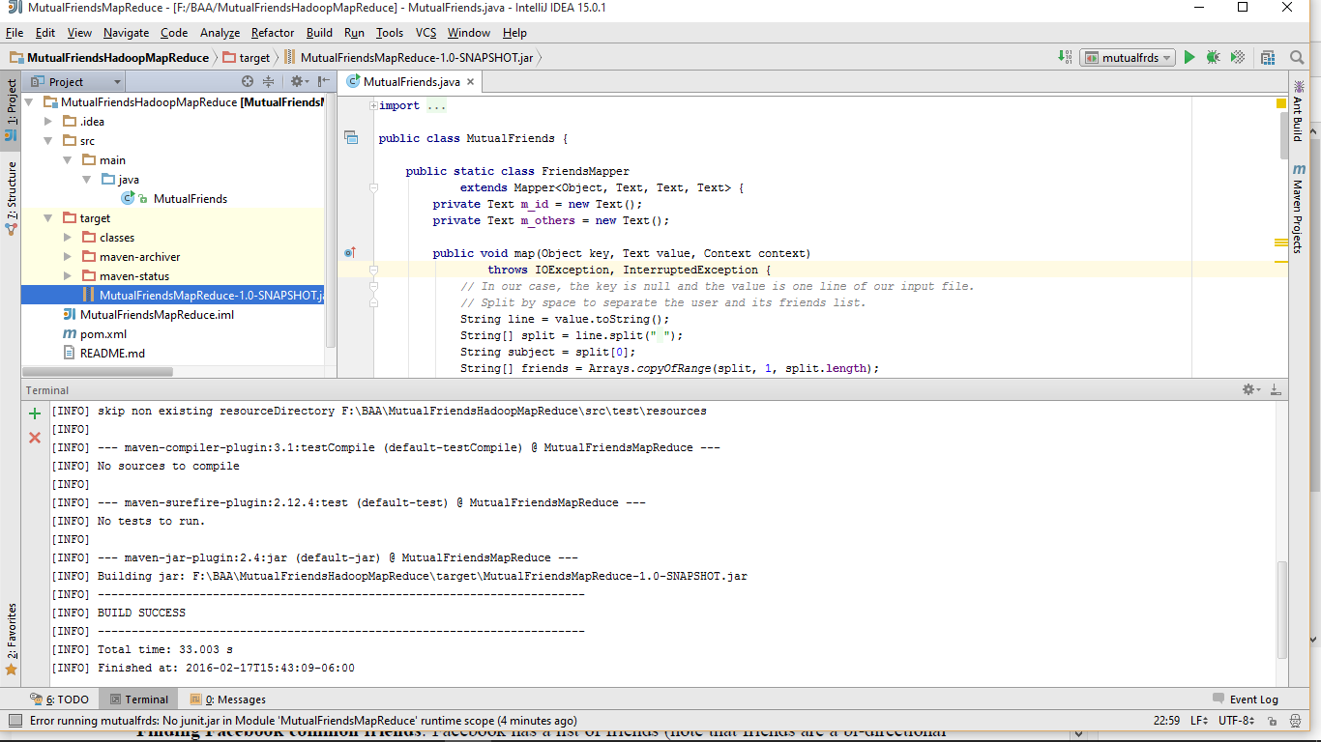

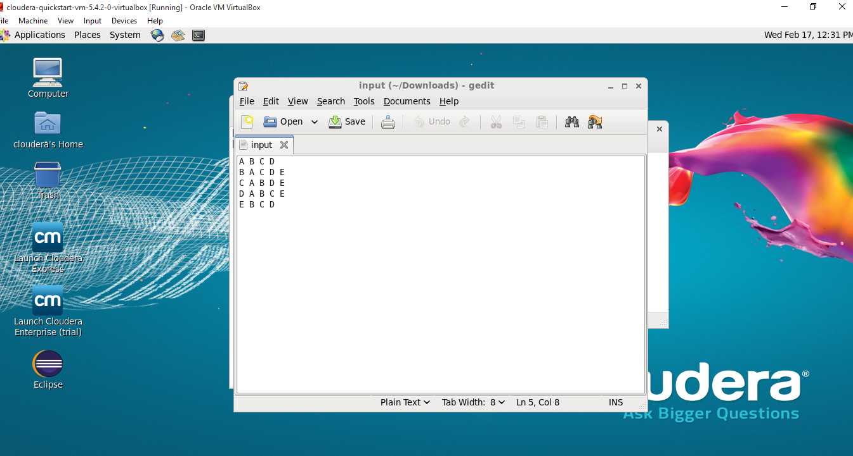

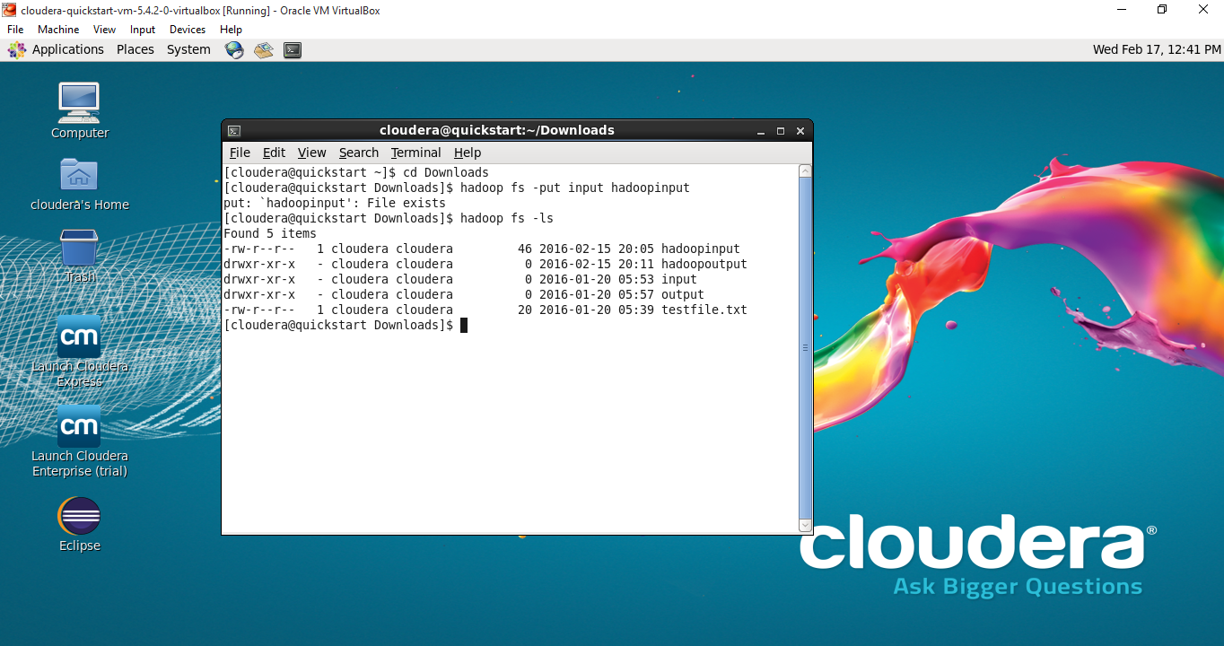

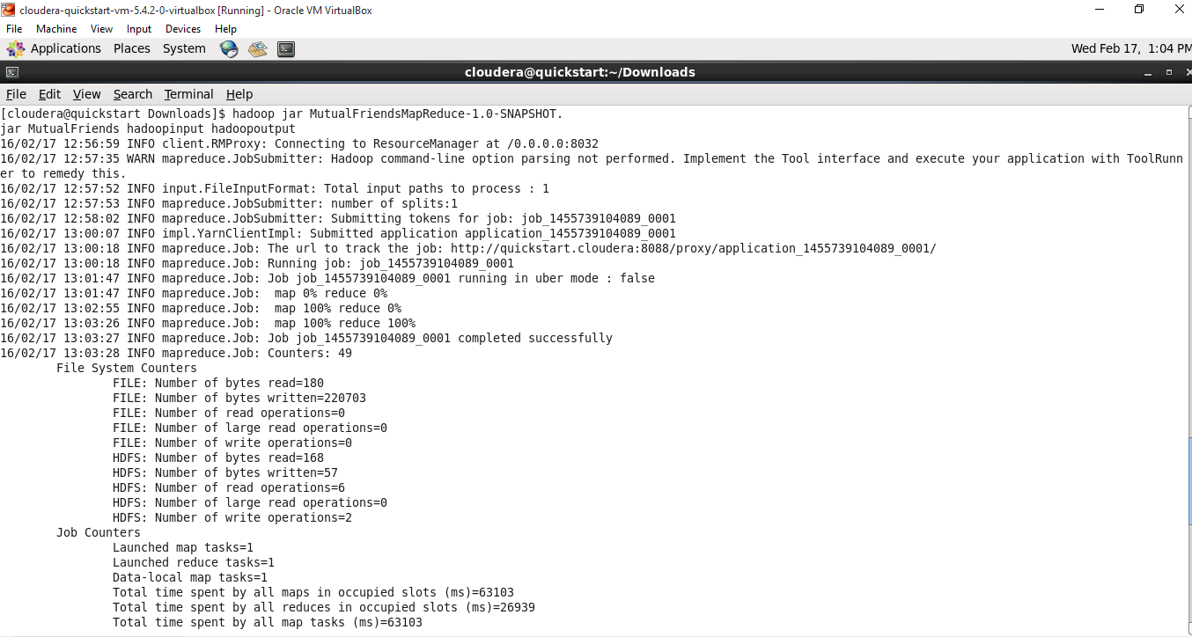

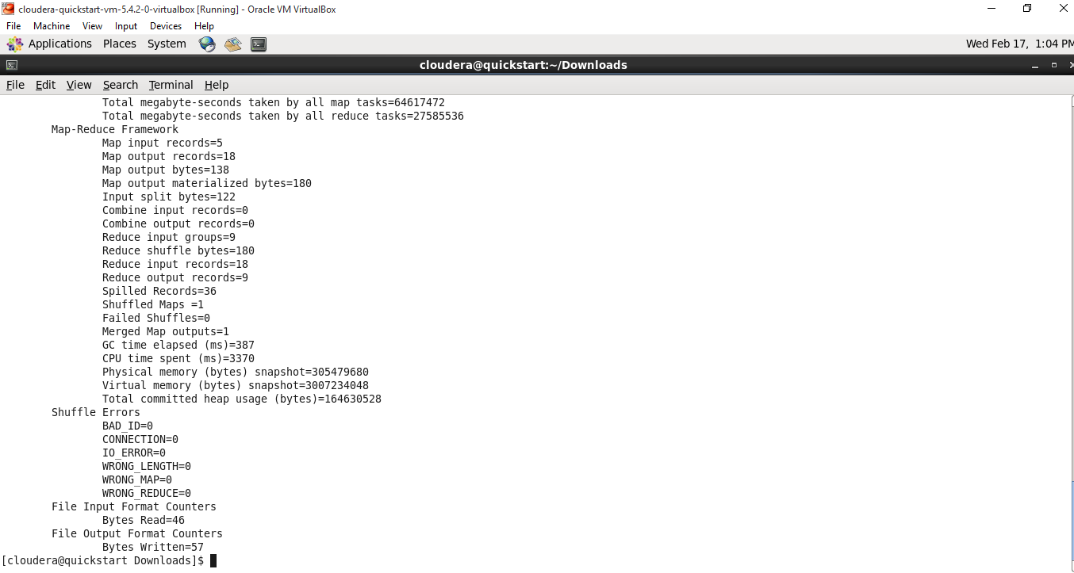

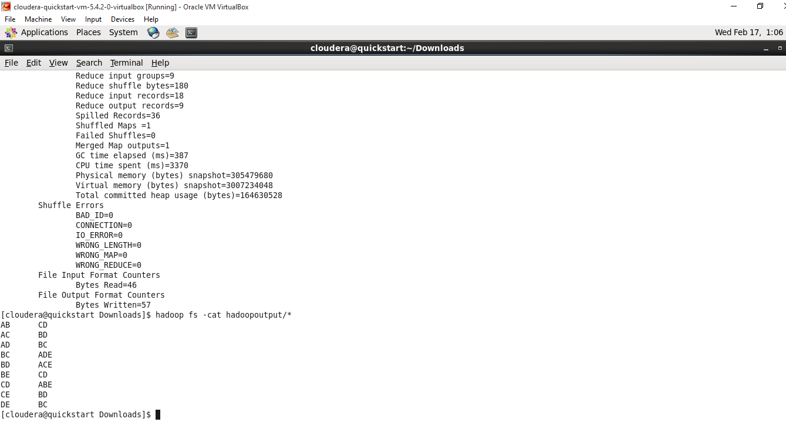

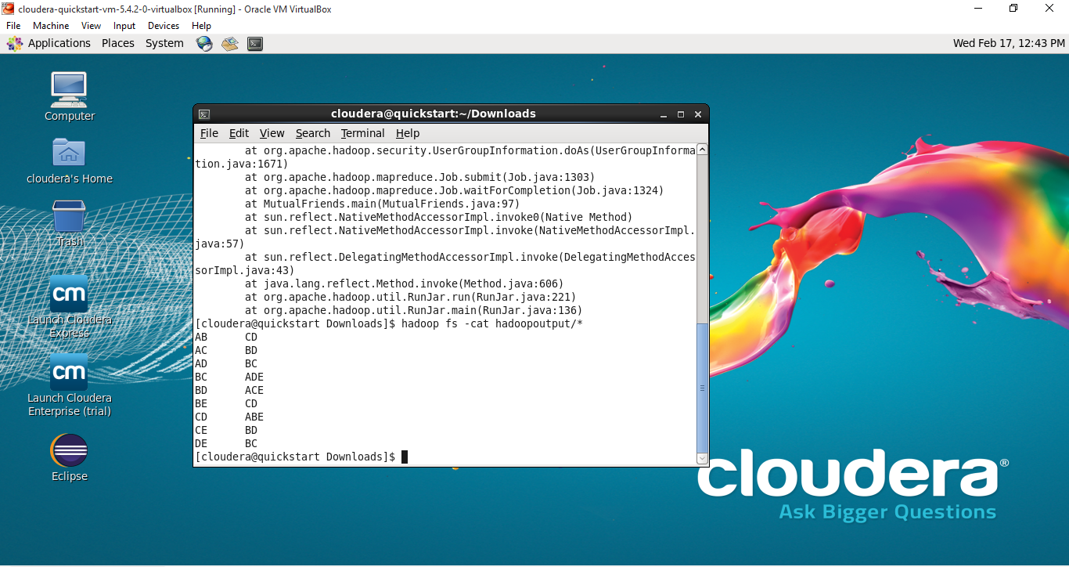

2. **Smartphone/Watch Application**

**Implement a smartwatch/smartphone application using existing speech services/image services (e.g., IBM Alchemyapi, Face++) related to your project.**

**Description:** This application uses IBM alchemy API. What it does is, it takes the image and tell us what it is. The results are shown below.

